**Lab 1 – Intro to Vivado**

CECS 341 – Computer Architecture & Organization

Kenry Yu, 028210726

Professor: Mandy He



California State University, Long Beach

College of Engineering

1250 Bellflower Blvd, Long Beach, CA 90840

January 28, 2022

**Goal/Objective:**

This lab aims to learn how to create Verilog modules, instantiate the top module in a test bench, and simulate it.

**Technical Description/Steps:**

I used Xilinx Vivado software in this lab. First, I created the project named “lab_1”, and then I did two design modules which are “FA.v” and “adder_2bit.v”. The “FA.v” is a full adder module that will be used in the “adder_2bit.v” file. I defined the identifiers and created the internal wire declarations to connect the inputs, outputs, and full adder. In the end, I used the test bench provided by my lab instructor to run the simulation.

**Results:**

I generated a schematic based on the design source code of “adder_2bit”. The schematic visually presented the internal wiring of the inputs to the full adder and from the full adder to the output.

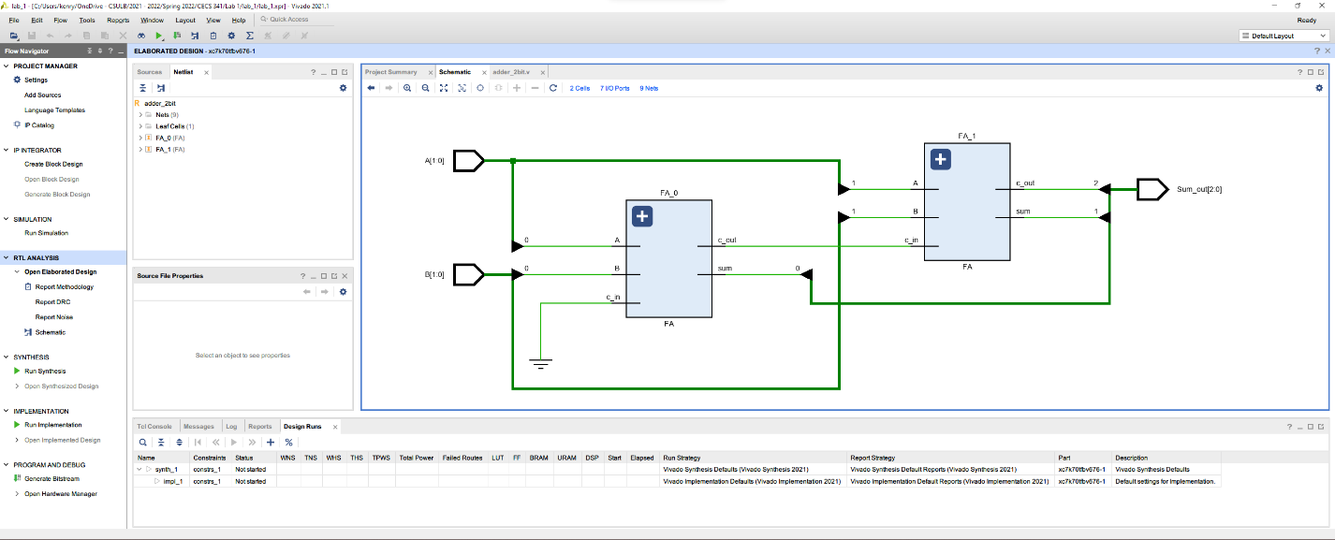

After that, I simulated with the test bench to show me the waveform, which shows the value change for each input and output.

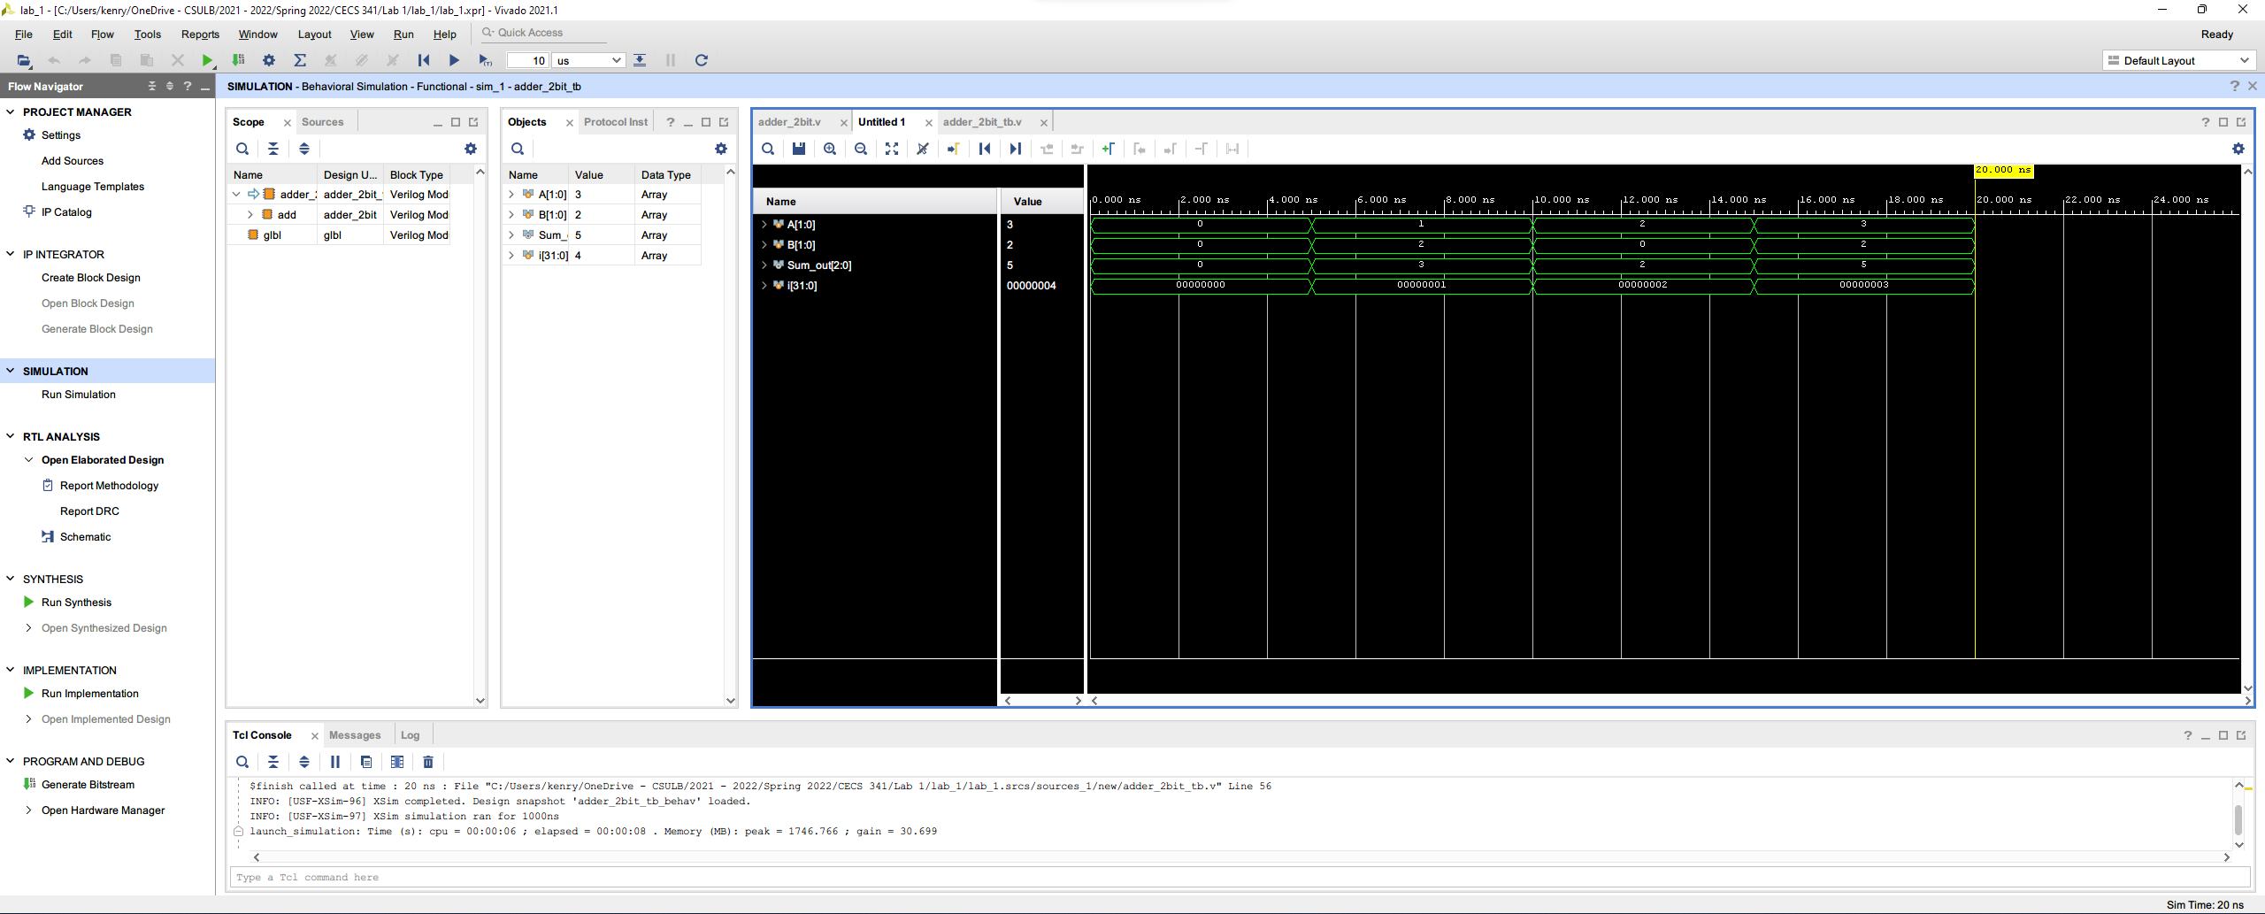

**Conclusion:**

I learned a couple of skills in Vivado, including creating projects, creating modules, wiring variables, running simulations, and creating visual presentations of the program. I ran into some difficulties while I tried to set the test bench as the simulation source, but after couple tweaking, I was able to run the simulation and generate the waveform for this lab.